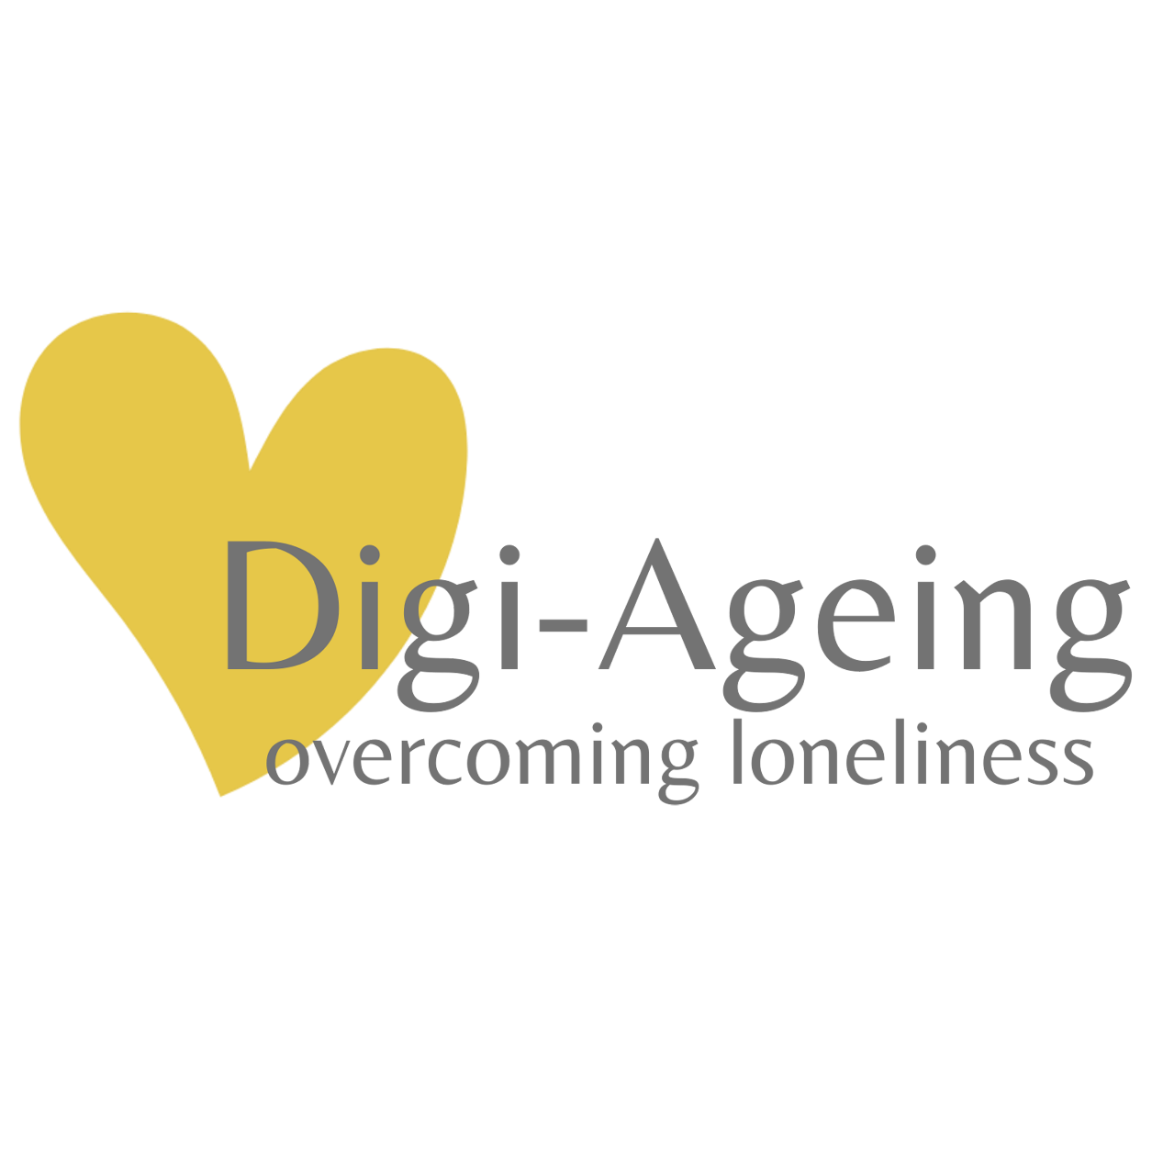

Digi-Ageing Training

Use Case Scenario

<insert country>

# **Use Case Scenario**

**Dear participants,**

based on the learning content, you are now required to apply the knowledge and skills you have acquired in the context of assessment, prevention, and implementation of coping measures.

Please proceed as follows:

1. Create an individual, **fictitious biography of an older person** (you will receive a template). In addition to socio-demographic data, you should also describe the characteristics of this fictitious person that could influence the experience of loneliness (positively or negatively).
2. Go together in pairs.
3. Find a quiet place where you can talk in private.
   1. One person now takes the role of the health professional (e.g., caregiver) who collects information and data on the situation of loneliness in a structured way.
   2. Together, the **Digi-Ageing tools are applied** (LQC, Eco-Map, UCLA-LS, ...).
   3. In a face-to-face conversation, item-specific indications of causes of loneliness (assessed with the UCLA-LS) are focused on in more detail and documented in order to be able to work out suitable measures.
   4. Relevant information is documented on the template.
   5. At the end of the interview, the health professional completes the case report in memo form.
4. **The roles are then exchanged**, and the procedure described is repeated.
5. After completion, the health professional works individually to **define measures and their evaluation** (timepoints, methods), which were planned on the basis of the data and information collected during the assessment interview.
6. The experiences made during this practice will be reflected and discussed together.